Does the wave change profile in x

Short answer: yes.

Is it always a front heavy wave: Yes

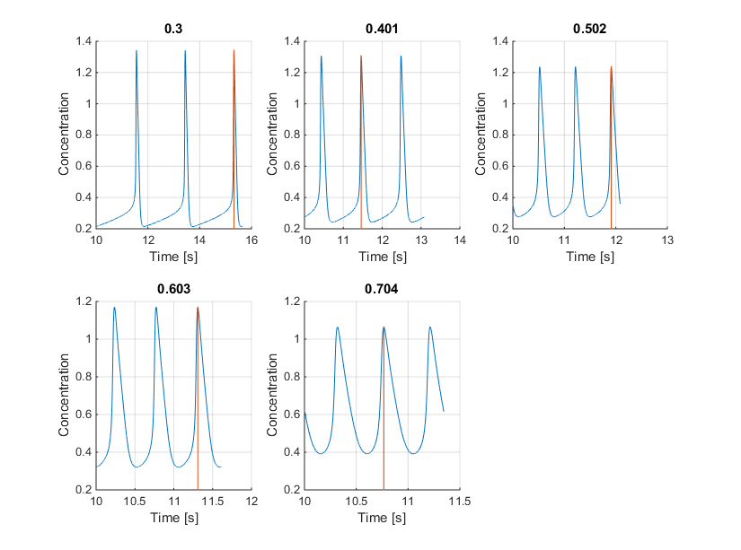

There are two sections to the wave: the wave front and the wave back split by the minimum

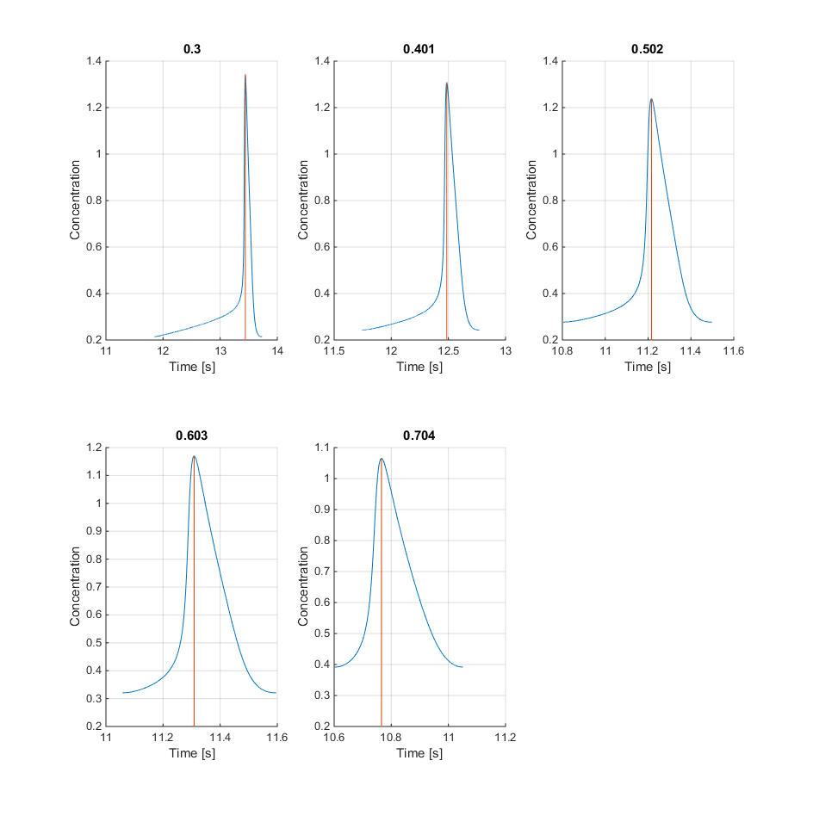

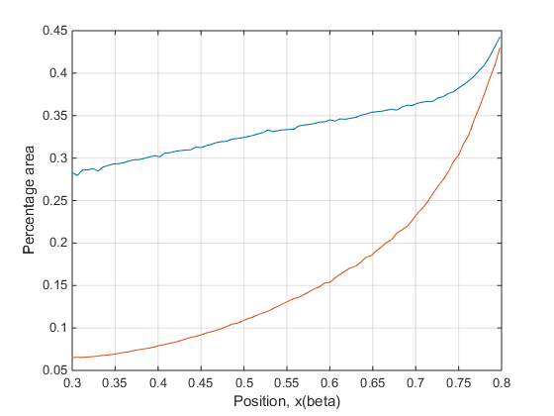

The percentage area is greater in the front ie Front heavy. Becomes more front heavy the lower the position.

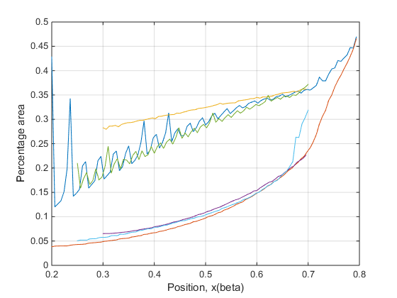

Holds true during Diffusion (Blue and red for diffusion 10s), (light blue and green for diffusion for 15s), (Yellow and purple zero diffusion)